How to View Your School Employee Time Off
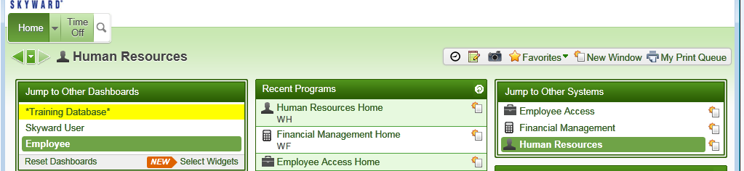
First, you need to make sure that you are in “Human Resources”

Then click on “Time Off”. Then click on “Time Off Limited Access”
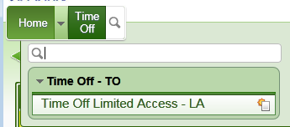

The next screen that comes up will show you all of your employees. I want to look at the time off for Mary Smithskr. I will click on the arrow left of her name…..Then I will have drop down menus to choose from.

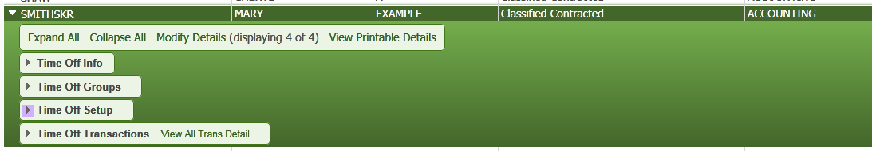
I like the “Time Off Setup”. Click on the left arrow and you will get another drop down.

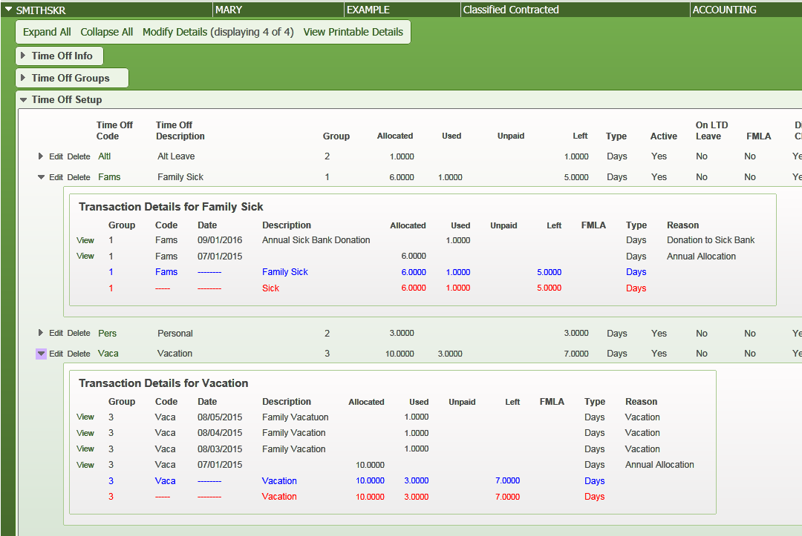
From here I can see that Mary has allocated 6 Family Sick days and used 1. And 10 Vacation days and used 3. When I click on the left arrow I can see exactly what days.

If you click on the left arrow in “Time Off Transactions” you can see everything also. It all depends on what you are looking for.
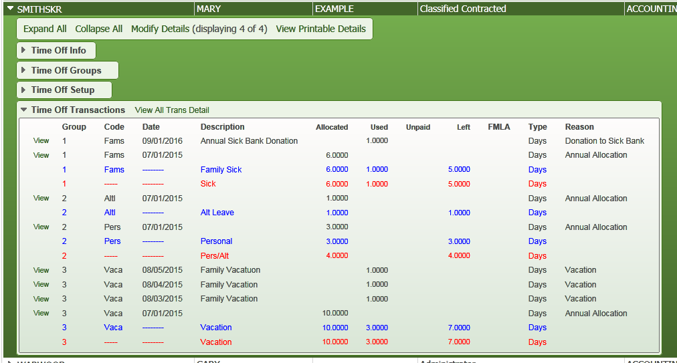
Q: Why does the Pers/Alt have the number 4 in red but in Personal it only shows a 3 in blue?
A: The Alternative day is 1 and the Personal day is 3. 1+3=4 (Alternative days and Personal days are always grouped together no matter what the total is)
ANOTHER EXAMPLE
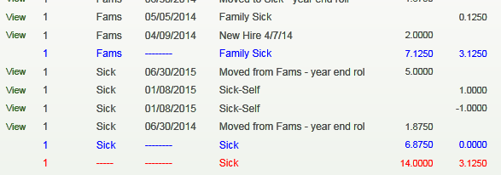

Here the Family Sick and the Sick are grouped together. 7.125 + 6.875 = 14

REPORTS
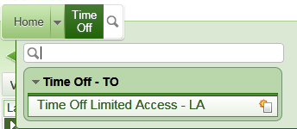
First Click in “Time Off” and “Time Off Limited Access”

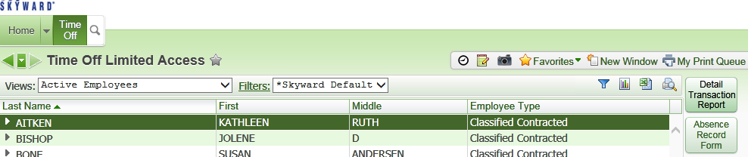
Now click on “Detail Transaction Report”

You will now “Add” your own report for the first time and then it will always be there and you will only need to change the date ranges.
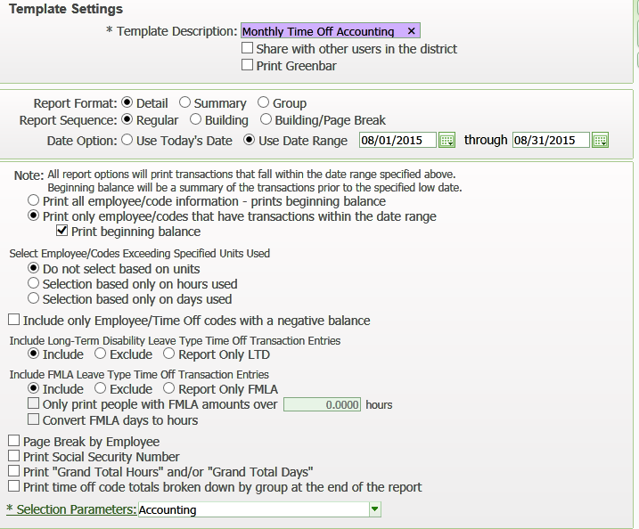
Name your report.
Fill in the radio buttons and choose your date range. Uncheck any buttons that are un-needed. This is exactly what you need.

Click on “Selection Parameters” and “Add”
From here, you will choose your information, but here is an example

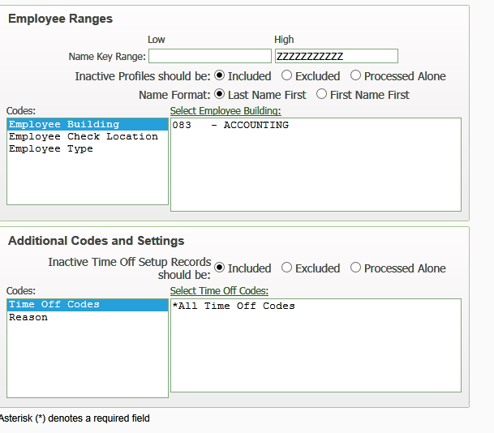

Now you will run the report. Next month when you run the report everything will already be set up, just put in new date ranges. My report shows the entire department, but I am only showing you the portion for Mary.
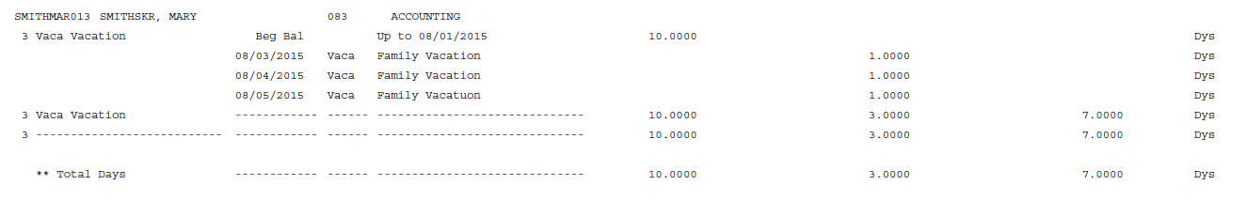
If I want to run a report with each person on an individual time off paper, I can run it like this….
Click on “Absence Record Form”
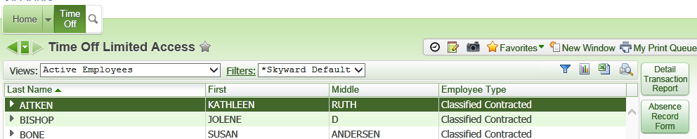

Click “Print”
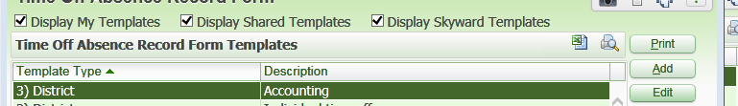

And now you will have everyone each individually printed off
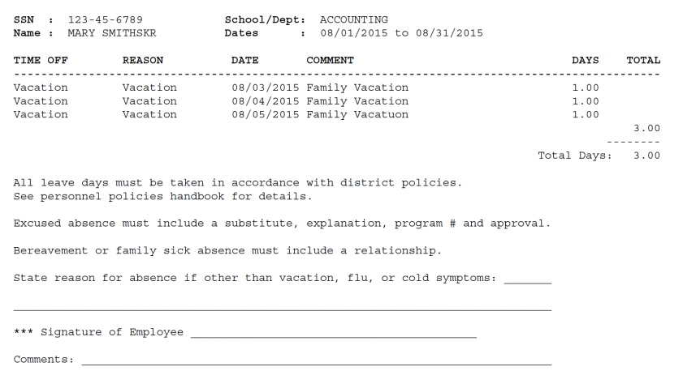

If you need any help running or printing reports, call the help desk at 801-826-5544 and they can help.

