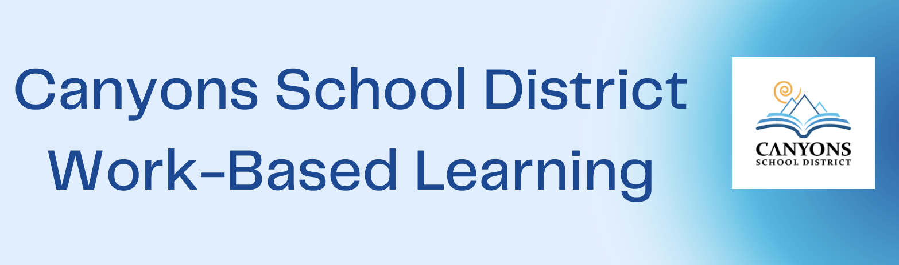

Vision of Success
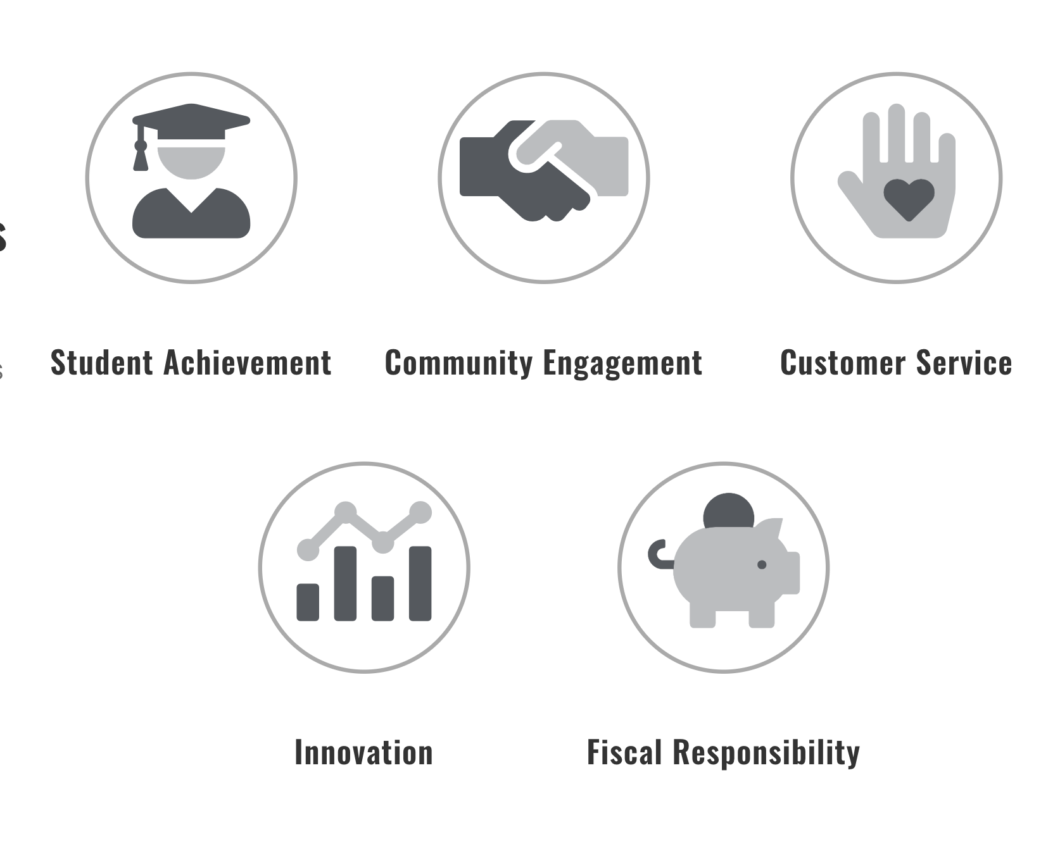
Canyons School District's vision is that every student who attends Canyons School District will graduate college and career- ready. The Canyons School District Work-Based Learning team partners with businesses and higher education institutions to help students visualize what is possible, chart a plan for their futures, provide hands-on experience, and expand their professional networks through work-based learning. Canyons School District Strategic Plan
Overview
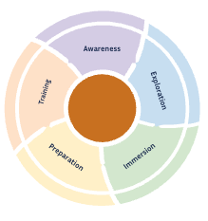
Work Based Learning allows students to see how classroom instruction connects to the world of work and future career opportunities. The Canyons Work-Based Learning facilitators plan and implement a variety of activities throughout the district at every grade level. These activities support students in developing career awareness, exploring career options, developing appropriate workplace skills, and relating academic skills to real-world applications.
Work- Based Learning Activities Include:

Awareness | Exploration | Intentional Preparation | Connections
Connections made to business and industry partners to introduce students to various types of careers. | Activities designed to promote a deeper understanding of potential careers, and to provide opportunities for investigation of a particular industry, career(s), or occupations of interest. | Pathway participation in coursework and workplace experiences that leads to the development of industry-identified skills needed for a Connection experience. | Activities that facilitate student entrance into the workplace.
- Elementary Career Fairs  - Guest Speakers  - School Tours  - Vehicle/Tool Days | - Career Fairs  - Guest Speakers  - Industry Tour  - Reality Town  - Job Shadows  - Workshops | - Industry Certification  - Job Preparation Skill Development  - Identification of Interests and Aptitudes  - CTE Pathway Concentration/Completers  - Mock Interviews  - Workplace Skill Lessons | - Internships  - Clinical Experiences  - Externships  - Apprenticeship  - Capstone Experiences
Career and Technical Education in Utah
Career and Technical Education provides all students access to high-quality, rigorous career-focused programs that result in the attainment of credentials with labor market value. CTE At-A-Glance Flyer
Utah CTE Career Clusters and Pathways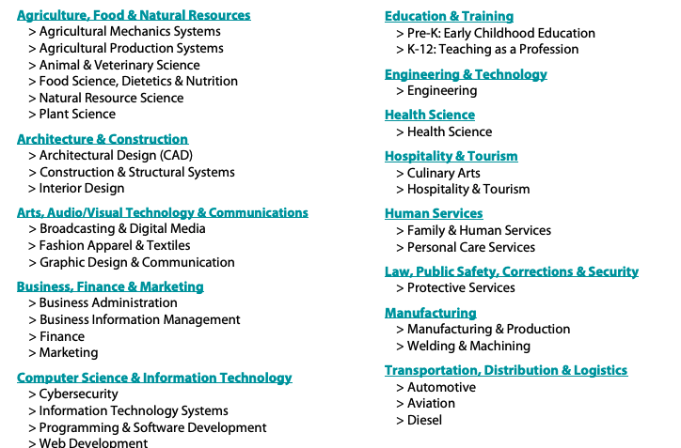
Work-Based Learning Experiences Explained

Experience | Purpose | Time Commitment | Grade Level | Approximate # of Students
Career Fair  (Elementary) | To create awareness of future career opportunities. | 45 min-1 hour  (Typically, three or four 10 min presentations) | K-5 | 25 Students on average per class
Career Fair  (Middle School or High School) | To create awareness of the requirements and expectations of future career opportunities. | 30-40 Min Presentation | 6-12 | 25-100 students depending on the format and location of the fair
Guest Speaker | To create awareness and exploration of the requirements and expectations of future career opportunities. | One class period  30-60 Mins | 6-12 | 20-40 students in a class
Industry Tour | To allow students to explore potential career opportunities. | One to two hours.  Typically, two 30-40 min tours. | 6-12 | 20-35 students per group  *Can accommodate industry requirements
Reality Town | A hands-on curriculum that allows students to learn about the financial responsibilities of an adult. | For two hours, volunteers work the different reality town booths | 8th Grade | Half of the 8th-grade class per session. Typically, two sessions.
Mock Interviews | A simulated job interview for students. | One Class Period  30-60 Mins | 6-12 | 20-40 students per class
Internship | To provide work experience in a future desired career. | Minimum of 40 hours | 11-12 | Typically, one student per location
Job Shadow | To provide an opportunity to explore a future career of interest. | One to two hours. | 6-12 | Typically, one student per employee

Canyons School District Work-Based Learning Team

Patti Larkin  CTE Specialist | patricia.larkin@canyonsdistrict.org  801-826-5512  385-246-6303
Janet Jefferson  WBL Facilitator  Alta, Indian Hills | janet.jefferson@canyonsdistrict.org  801-826-5666  801-243-8782
Eileen Kasteler  WBL Facilitator  Brighton, Albion, Butler | eileen.kasteler@canyonsdistrict.org  801-826-5842  801-712-0143
Cher Burbank  WBL Facilitator  Hillcrest, Midvale, Union | cher.burbank@canyonsdistrict.org  801-826-6047  801-842-7567
Jennifer Boyd  WBL Facilitator  Jordan, Mt. Jordan, Eastmont | jennifer.boyd@canyonsdistrict.org  801-826-6255  801-368-1841
Natalie Thorell  WBL Facilitator  Corner Canyon, Draper Park | natalie.thorell@canyonsdistrict.org  801-826-6543  801-300-1746
Jared Vincent  WBL Facilitator  Diamond Ridge, All Elementary Schools | jared.vincent@canyonsdistrict.org  801-826-  810-558-0843
Emalee Brown  CTE Coordinator | emalee.brown@canyonsdistrict.org  801-826-6621  626-376-1927

Interested in getting involved?
Check out our annual CTE Work-Based Learning Calendar for information about our upcoming events.
Complete this survey to let us know how your company would be willing to partner with Canyons School District Work-Based Learning to offer high-quality experiences for our students.

Guidelines
The WBL team will review the survey results every month and reach out to the industry partner or post-secondary institution, as each Work-Based Learning event is planned throughout the school year. If you have immediate questions or concerns, reach out to the CTE Specialist Patti Larkin.
Important Links
CSD Volunteer

