Developing SMART Goals Through Self Assessment
Teacher Learning Goals | Student Performance Goals
- Linked to the needs of the students, but driven by the needs of the educator  - Tied to school and team goals  - Measured through public practice application data | - Driven by the students’ achievement needs  - Measured by student performance

Canyons Framework for Instruction

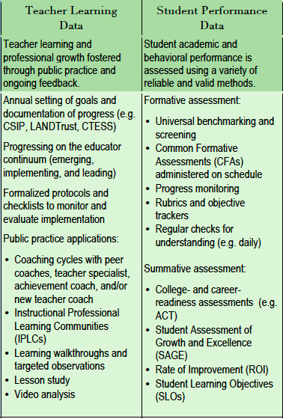

The SMART Goal framework guides development of both Teacher Learning and Student Performance Goals so that they are clear and measurable.

S | Specific and strategic goals are narrowly focused and likely to impact student performance.
M | Measurable goals are quantifiable so that progress can be evaluated.
A | Action orientated goals include action steps for the educator to follow.
R | Rigorous, realistic, and results focused goals are ambitious but achievable with specific outcomes.
T | Time-bound and tracked goals have a timeline to measure results and track progress.
Sample Goal

Goal | SMART Goal
I will improve my 8th grade students’ mathematical literacy in geometry. | In order to ensure mathematical literacy in each of the three content areas for eighth-grade geometry, I will incorporate essay questions into unit assessments that require elaboration of mathematical reasoning so that by the end of the 2014–15 school year, 80-percent or more of my students demonstrate proficiency on essay questions on the end-of-the-year eighth-grade geometry assessment.

SMART Analysis

S | Is the goal specific and strategic? | Yes. The goal is narrowly focused on “three content areas for eighth-grade geometry” and involves the incorporation of “essay questions into unit assessments that require elaboration of mathematical reasoning.”
M | Is it measurable? | Yes. The goal calls for “80 percent or more” of students to demonstrate proficiency.
A | Is it action-orientated | Yes. The goal uses action words such as “ensure,” “incorporate” and “demonstrate.”
R | Is it rigorous, realistic, and results focused? | Yes. The goal sets high but attainable expected outcomes for students and the educator.
T | Is it Time-bound and tracked | Yes. The goal should be met “by the end of the 2014-15 school year.”

Steps in developing Teacher Learning Goals as part of the CTESS Self-Assessment

- Step 1: Review your school and team goals and relevant student data as well as previous evaluative feedback

Aligning your Teacher Learning goal to the goals of your team, the school, and the district, increases the likelihood that you will receive support and achieve the professional growth you set out to accomplish. Additionally, the easiest way to accomplish broader team or school goals is for educators to work together on instructional practices most likely to impact student outcomes.

- Step 2: Select one of the CTESS Standards you have prioritized for improvement this year that also aligns with your school and/or team goal

In the first part of the CTESS Self-Assessment, you will identify some Standards as “High” Priority for Improvement based on your reflections of your current implementation levels as well as any prior feedback you’ve received through coaching or prior evaluations.

- Step 3: Make a clear statement of what you would like to improve upon and why
- Step 4: Describe your plan for achieving your professional development goal
- Step 5: Determine how and when progress on your goal will be measured

Sample sentence frame for steps 3, 4, and 5:

Many of my students are struggling in _____________ because _______________. In order to increase my student’s performance in ________________ as measured by _________________, I will ____________________. My progress on this teacher learning goal will be evident in the following ways ___________________. As a result of these actions, my students will ____________ on _______________ by _______________.

- Step 6: Check that your goal meets the SMART goal criteria

- Step 7: Specify the evidence that you will collect to show progress toward your goal
I will collect the following evidence toward my goal:____________________________

- Step 8: Identify any potential supports you will need achieve your goal
To accomplish this goal, I will need: _________________________________________

