True Time enables employees to enter their time in and out using Skyward Employee Access. Supervisors can view employee’s time entries online to verify attendance and adhere to their schedules. Once the supervisor reviews and approves the timesheets, they are available in Payroll to integrate into Payroll Worksheets, increasing accountability and reducing payroll errors.
Accessing True Time
To access True Time Entry, go to www.canyonsdistrict.org.
Click on Skyward as highlighted.


The following screen will be displayed.
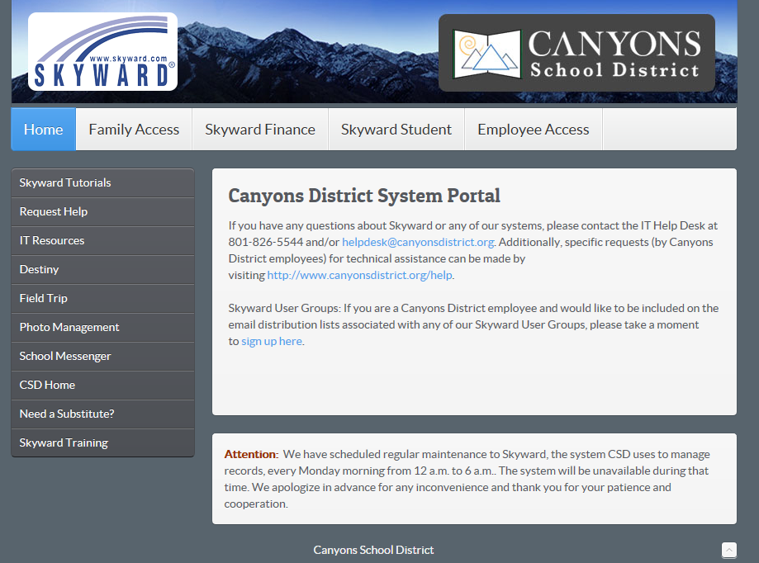
Click on Employee Access as highlighted.

The following screen will be displayed.
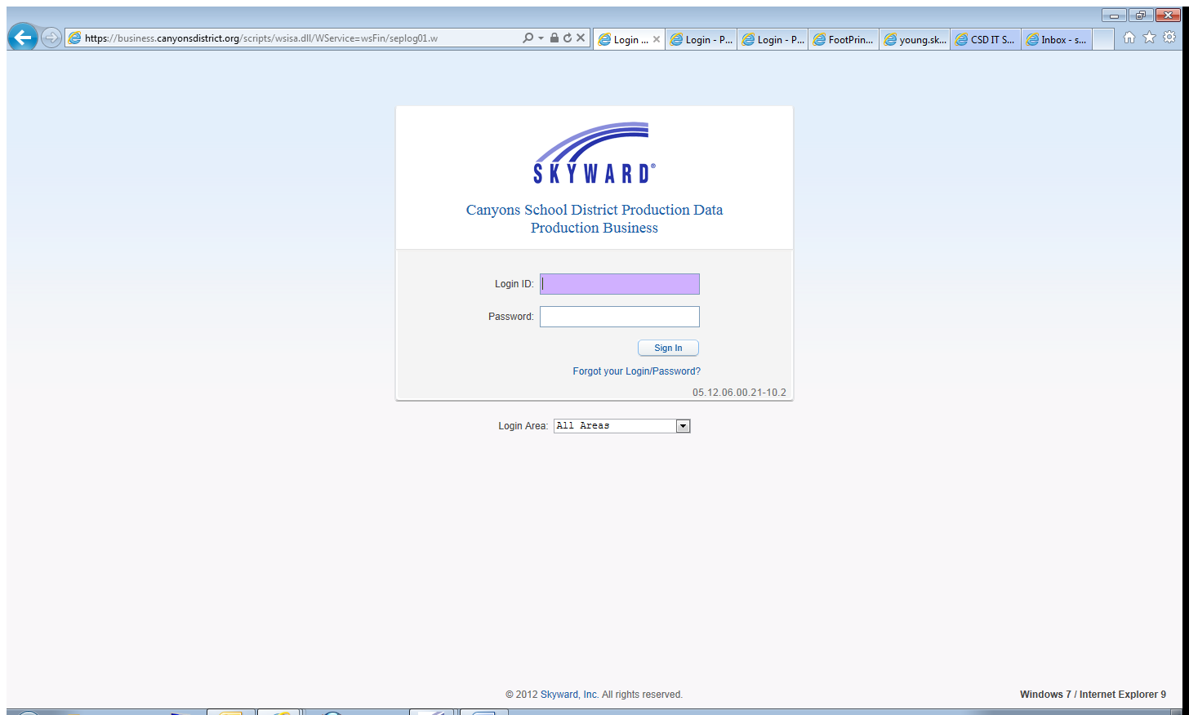
Enter you Login ID and Password. (If you have forgotten, call the IT Helpdesk 801-826-5544)
Press Enter or click the Sign In button.
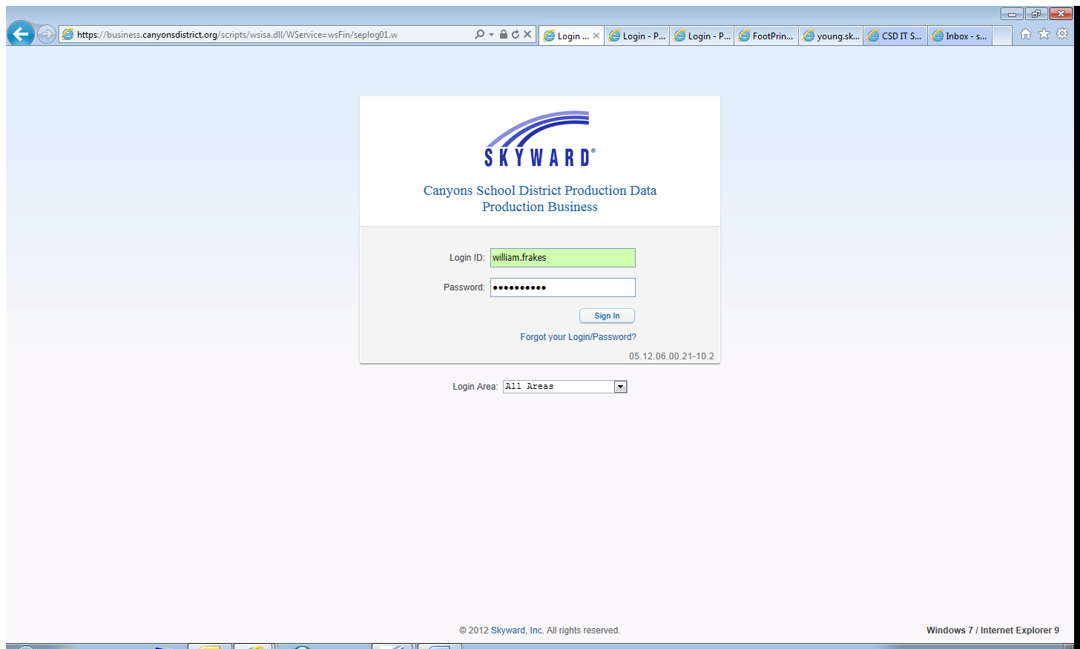
The following screen WILL vary by employee.
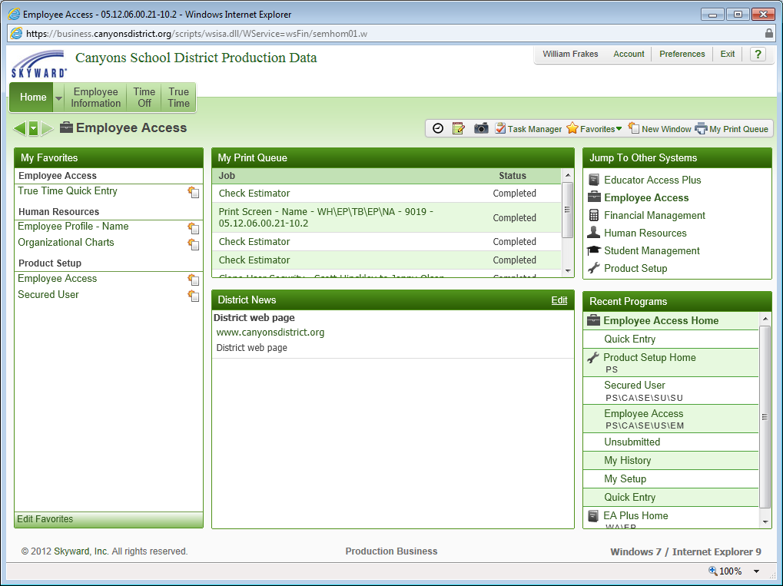
1
2

BOTH screens show Employee Access
In the above example, William, is logged into his Employee Access.
1
2

Now, Click either or This will take you to Quick Entry.

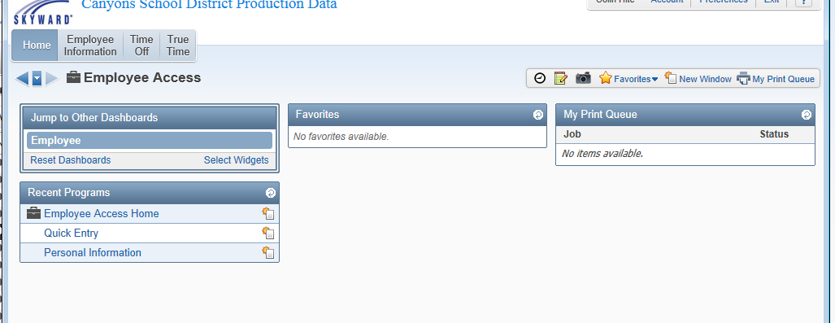
2

1

If you click on you click Quick Entry. If you click (the clock) it goes straight to Quick Entry.
2

1
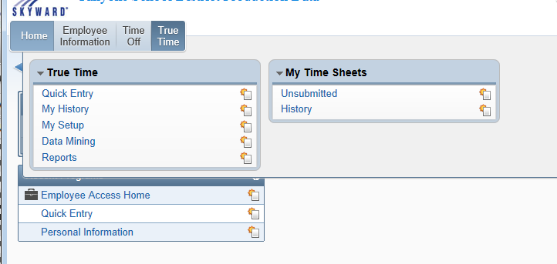
Quick Entry
The Quick Entry screen allows employees with True Time access to clock in and out.
The Quick Entry screen will also allow employees to see their Current Status and Totals.
Additionally, employees are allowed to adjust their times and submit their time sheets.
The following screen is displayed. To log in, click the In button as highlighted.
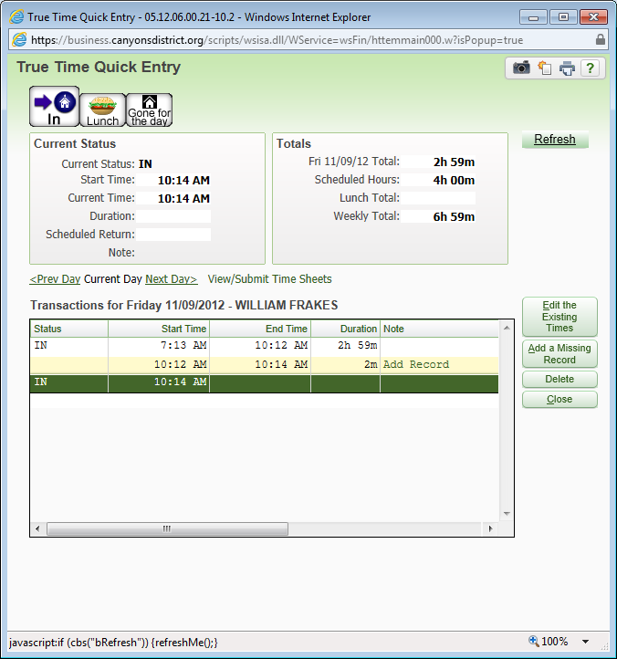
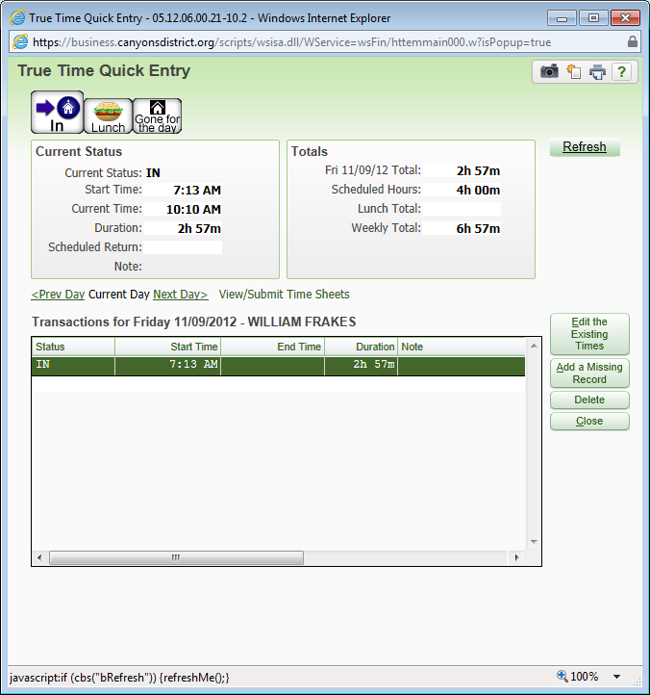

When you are finished for the day then clock out by clicking, “Gone for the Day”

In the following example William is taking a Lunch Break
To log in, click the In button.
If your schedule includes a lunch break, click the Lunch button to log out.
The screen will be displayed as follows.
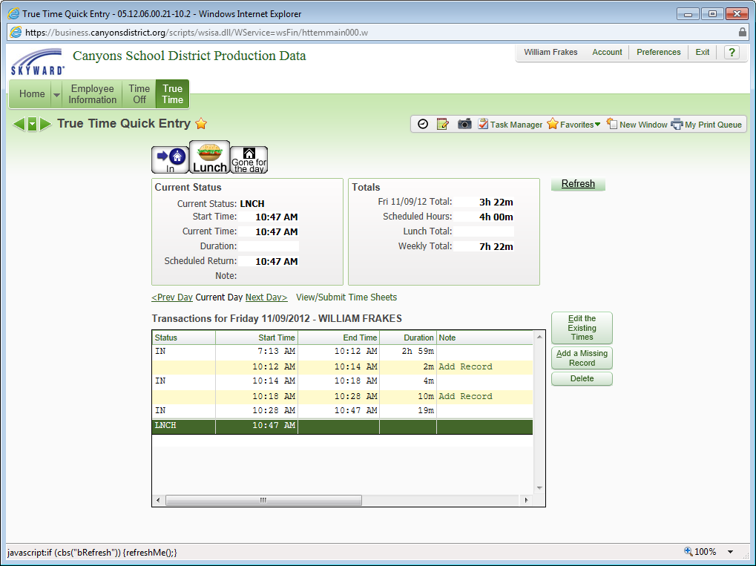
In the example, William logged out for Lunch at 10:47 AM.
To clock in after lunch, click the In button.
Remember when it is time to go home you must then again clock out; “Gone for the day”

Current Status
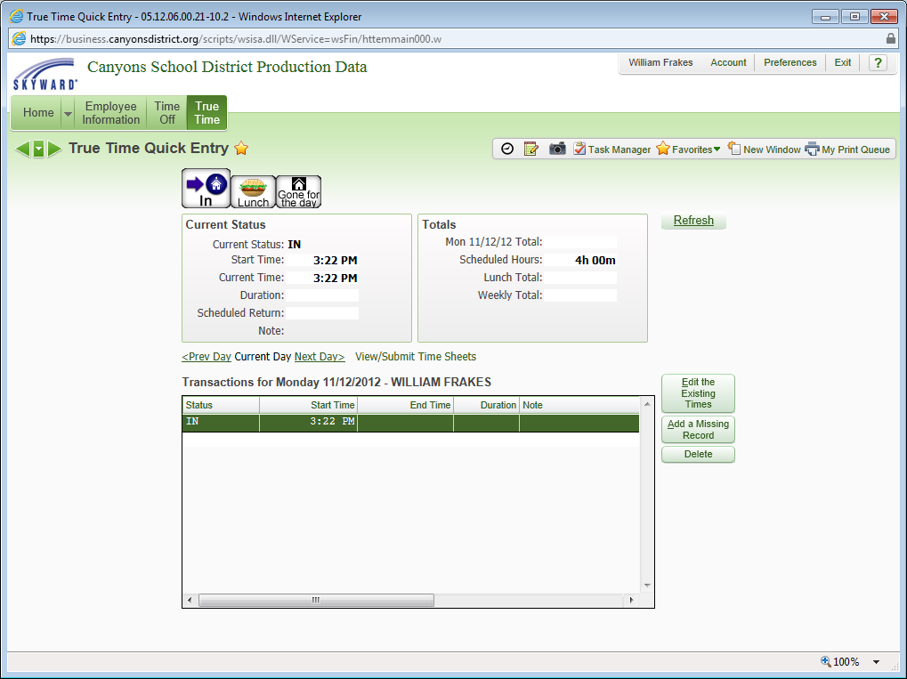
The Current Status area shows current information for the employee. The status will show if an employee is In, Gone, at Lunch, etc.
The Current Status also shows the Start Time, Current Time and Duration of the current action.
If the Current Status is Break, Temp Out of the Office, Lunch, Meeting or Work Out of Office, a Scheduled Return can be entered.

Totals
The Totals area includes total time worked that work week.
Editing the Existing Times
The Editing the Existing Times option is used to allow employees to edit their times.
Highlight the record that needs to be adjusted and click the Edit the Existing Times button as highlighted.
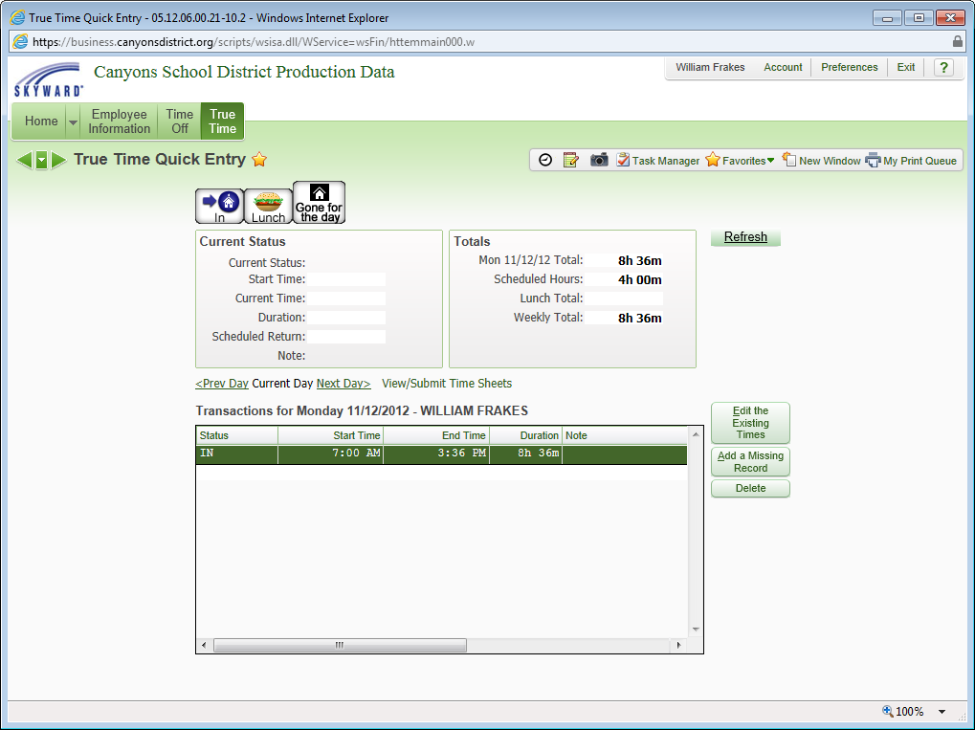
Employees will be able to adjust their Start Time and End Time.
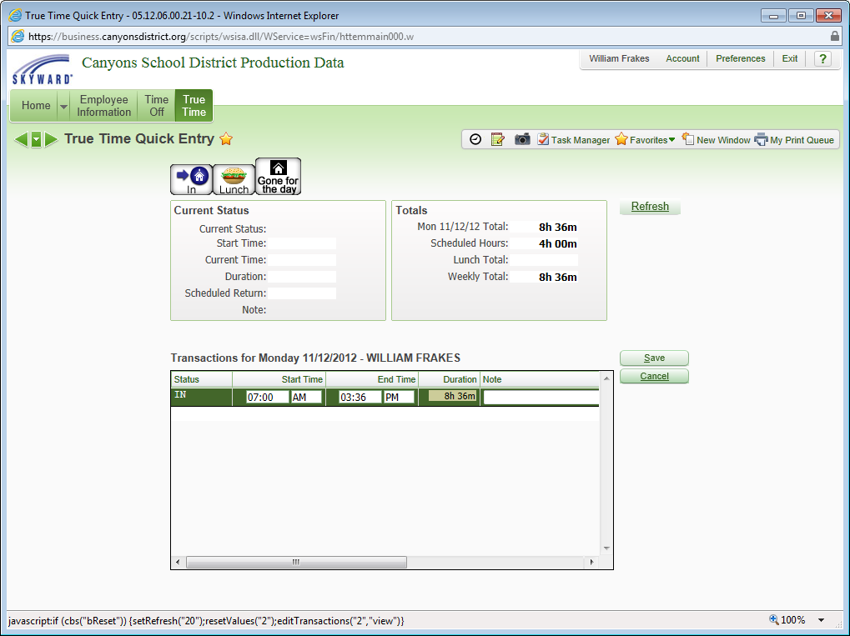
In the example, we will edit the End Time to 11:00 AM.

Click Save when complete.

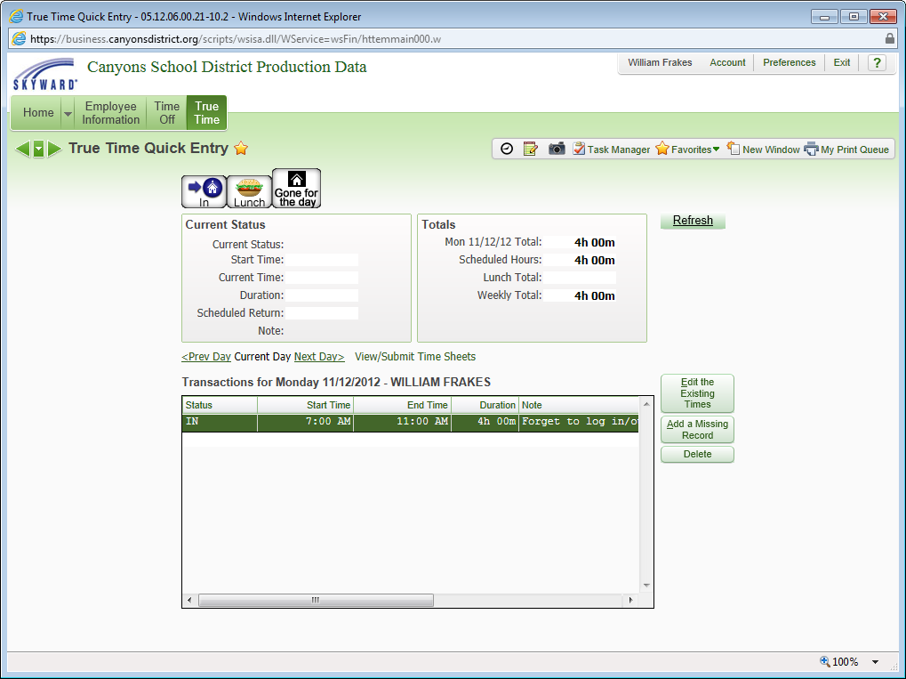
If the changes result in a gap in time, an Add Record transaction will be created.
This allows an employee to easily add a record to fill the gap in time if needed.
An adjustment record will display on the employee’s time sheet and Adjustment History screens to capture adjustments.

Add a Missing Record
The Add Missing Record button allows employees to add a transaction in True Time that currently did not exist.
Click the Add a Missing Record button as highlighted to create the record that is missing.
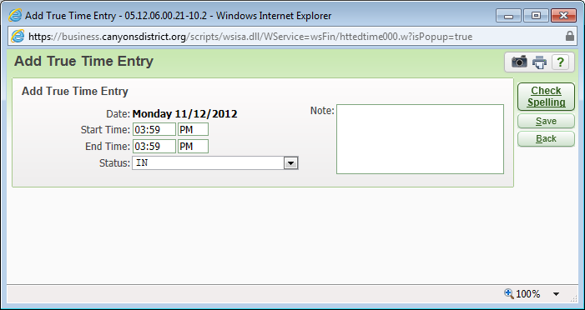
Notice the date. The entry will be added for the Current date.
Enter the correct Start Time and End Time.
Adjust the Status if necessary.
Enter a Note with a brief explanation of why you are manually adding the entry.
Click the Save button.
Delete a Record
The Delete option allows employees to remove a transaction in True Time.
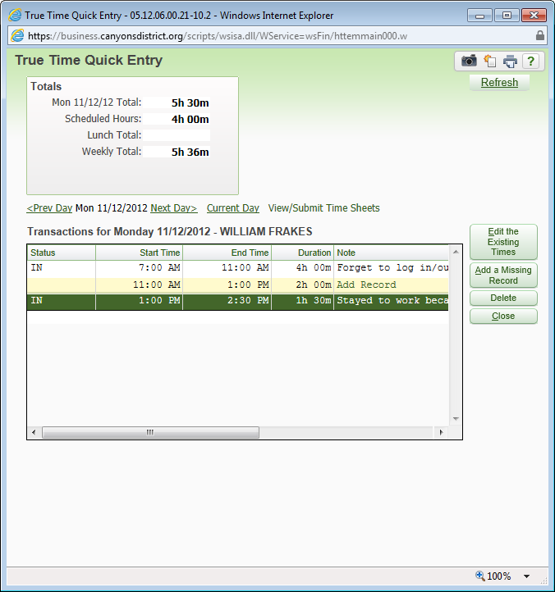
Highlight the record to be deleted.
Click the Delete button as highlighted.
A Confirm Delete message will appear, asking “Are you sure you wish to delete this record?”
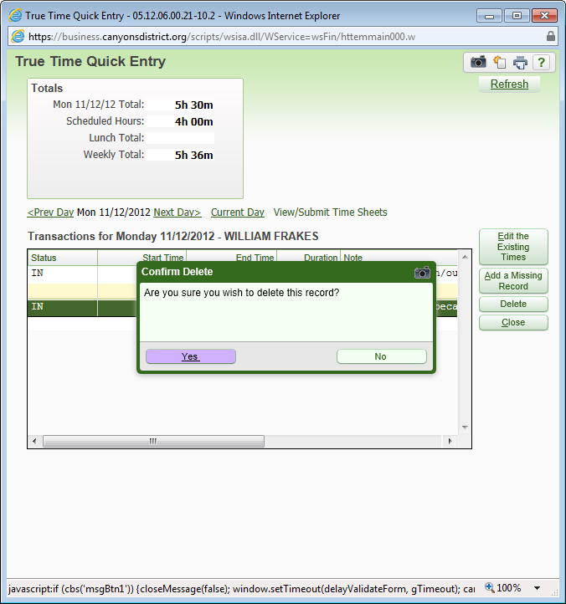

Click Yes to delete or No to keep the record.

Navigating between Work Days
The Current Day is displayed. To move between Prev Day and Next Day, click on the appropriate link as highlighted.
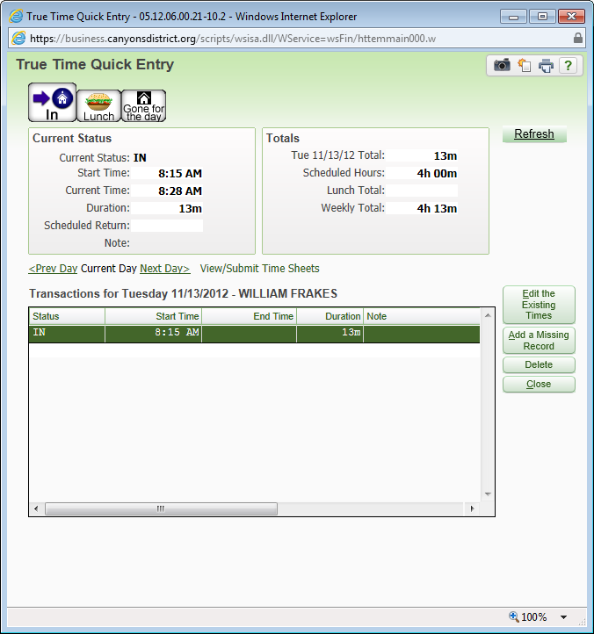
With the previous day displayed, you can perform any of the functions available while on Current Day such as Edit the Existing Times, Add a Missing Record or Delete.

View/Submit Time Sheets
From within the Quick Entry screen, you can also View/Submit Time Sheets.
Click on View/Submit Time Sheets as highlighted.
The My Unsubmitted Time Sheets screen will be displayed.

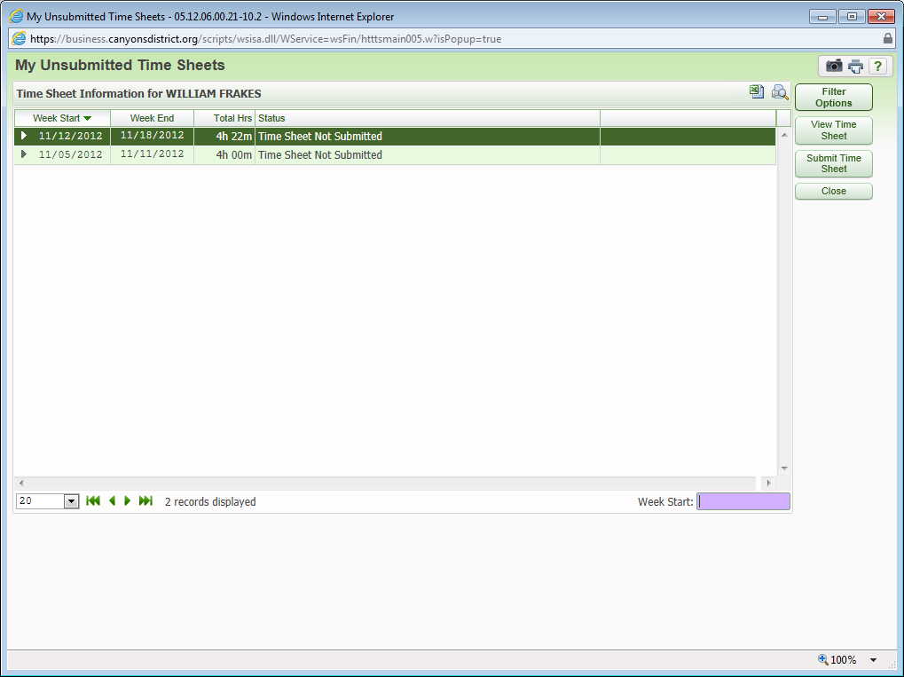
To view the Time Sheet, click the View Time Sheet button as highlighted.
The following screen will be displayed.

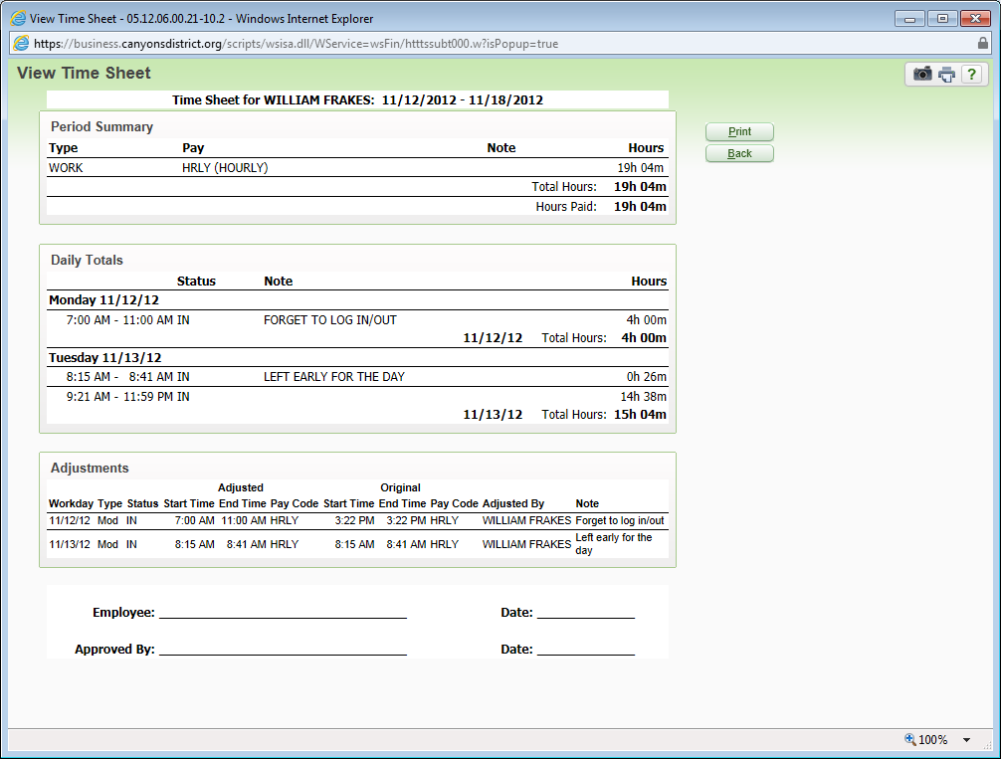
The option to print the Time Sheet is available by clicking the Print button as highlighted.
Click the Back button to return to the previous screen.
Note: You are not required to print and/or sign the weekly time sheet.
Submitting a Time Sheet
For Payroll to process your Time Sheet, the Time Sheet must be submitted and approved by your Supervisor.
To submit the Time Sheet, highlight the Time Sheet for the week and click the Submit Time Sheet button as highlighted.
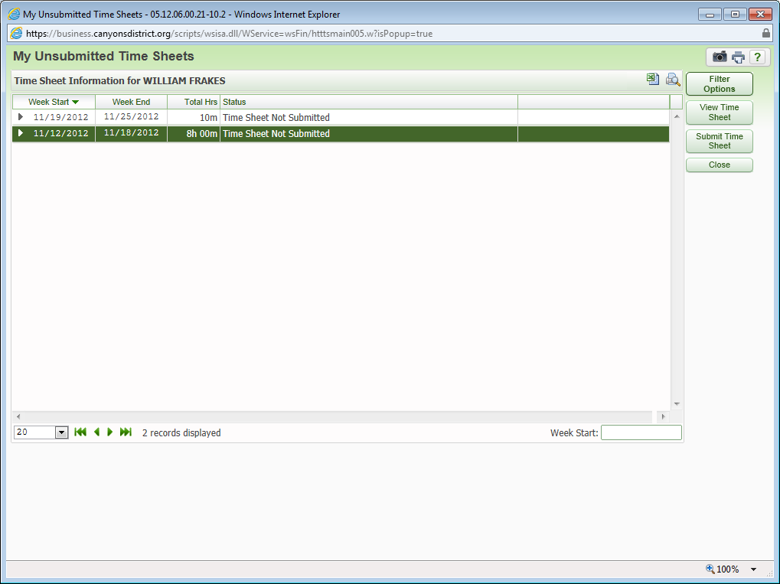
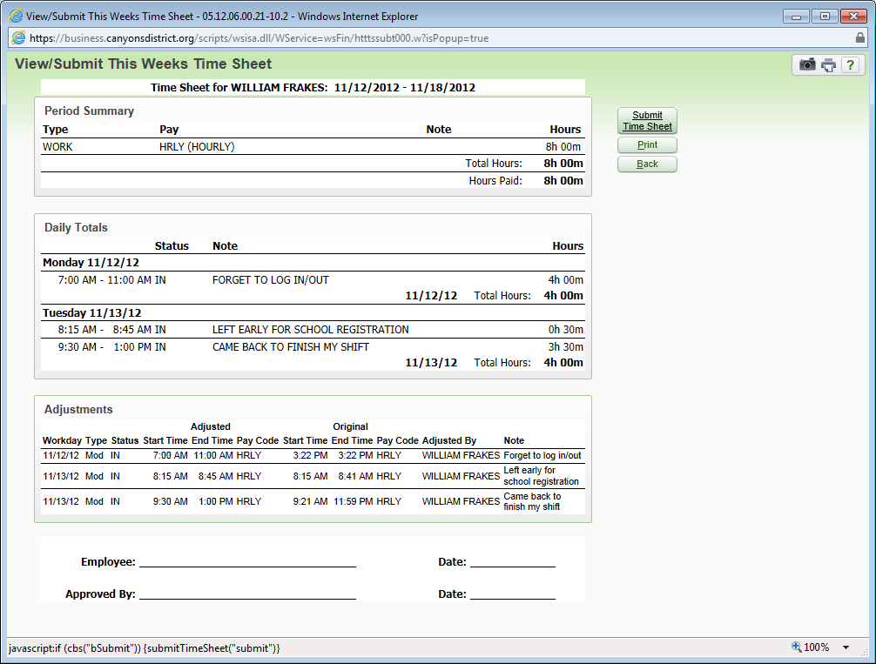
Review the Time Sheet for accuracy.
Click the Submit Time Sheet button.

You will receive a message with Time Sheet Submission Information.
You can add additional information about this Time Sheet in the Notes.
The Notes will be viewable by Payroll.
Click Save to save the Notes.
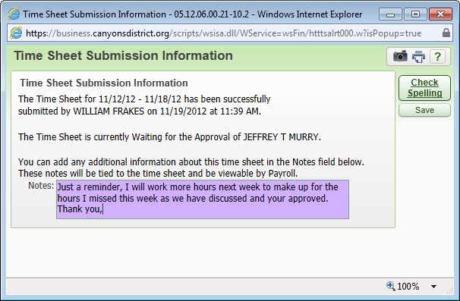
You can also submit your Time Sheet from the Unsubmitted option found under My Time Sheets shown as follows.
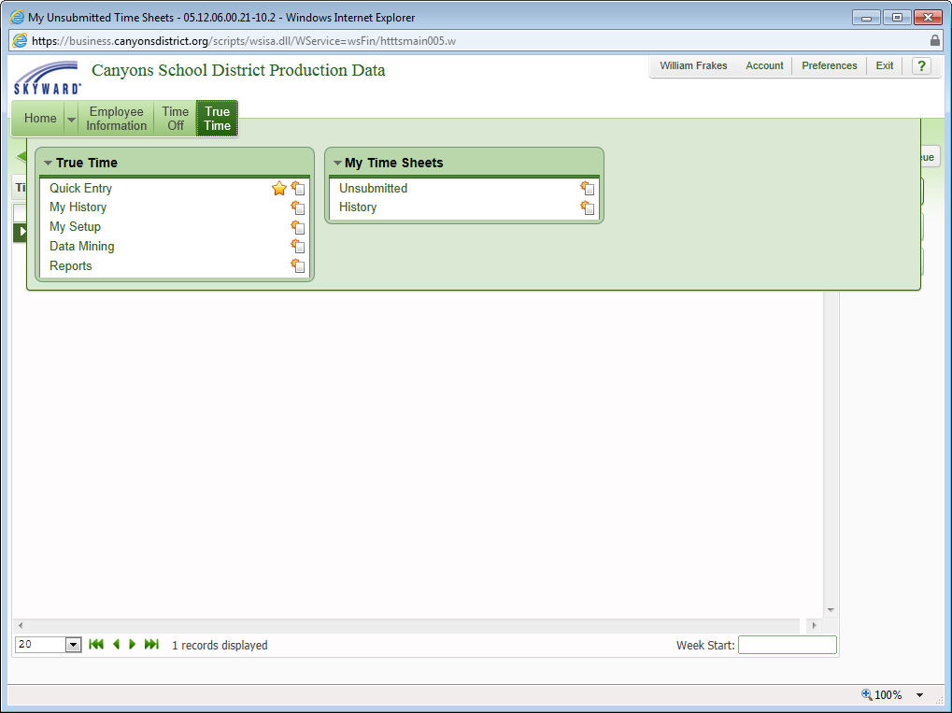
Follow the same steps as previously shown for Submitting a Time Sheet.
Time Sheet History
Time Sheet My History can be viewed in different formats from different screens.
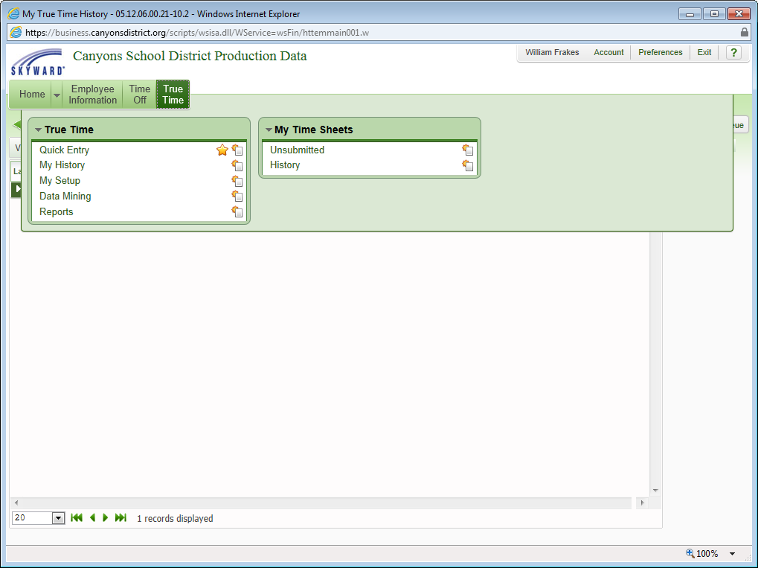
Click My History under True Time.
The following screen will be displayed.
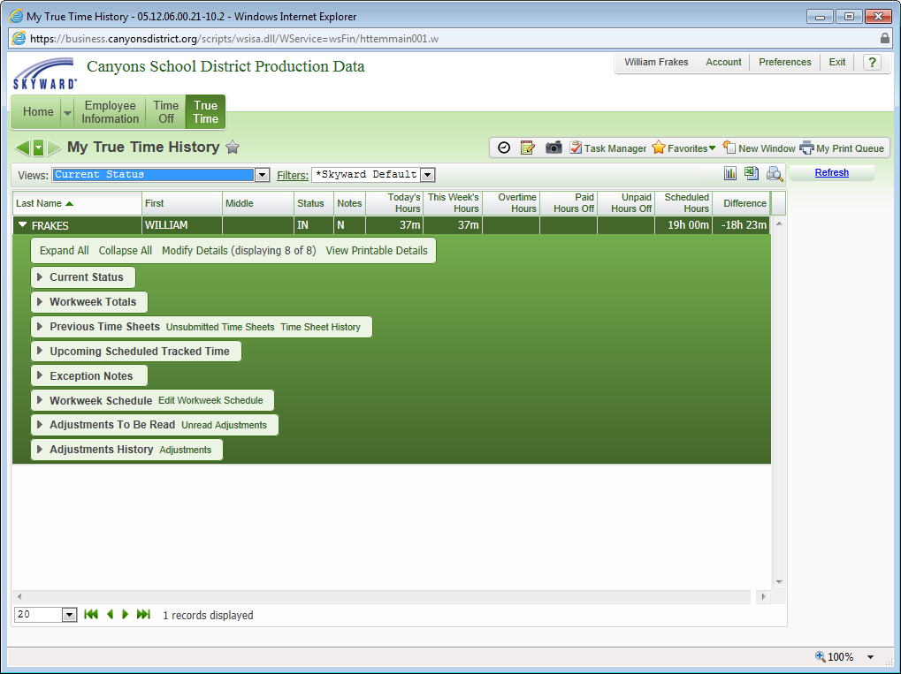
Click Expand All to expand all the information.
Current Status
Click the arrow to expand the Current Status.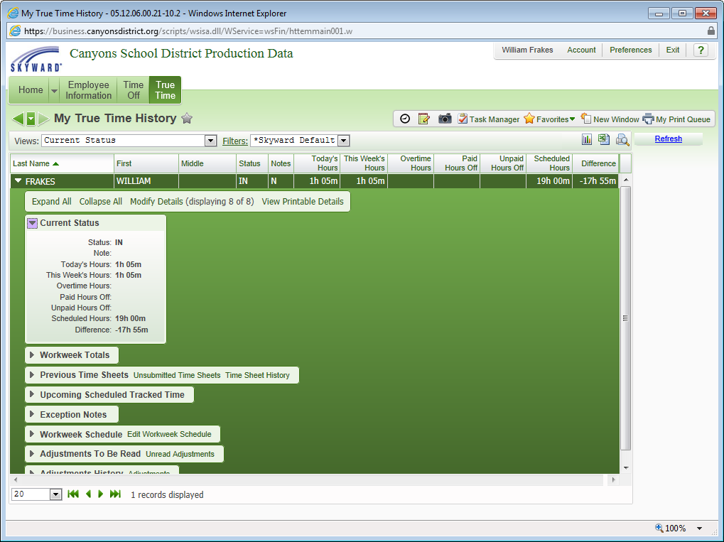
Click the arrow again to collapse the status.
Workweek Totals
Click the arrow to expand the Workweek Totals.
The Current Week is displayed.

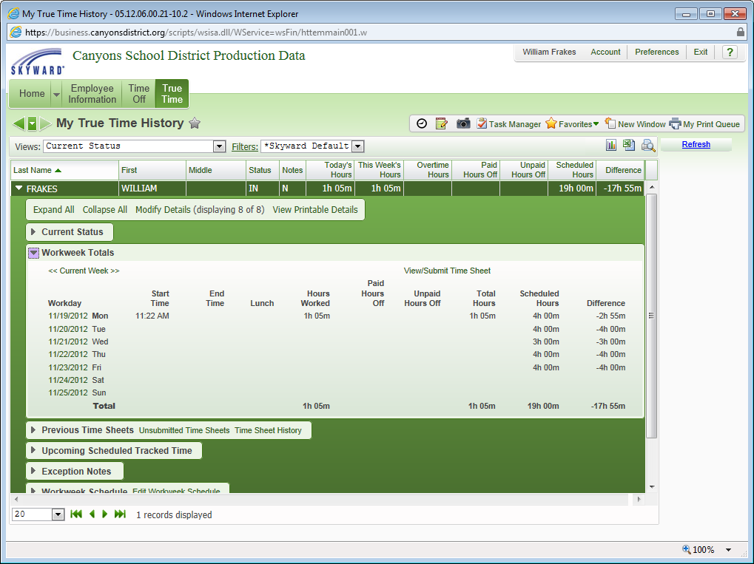
Click the arrows left of Current Week, the previous week is displayed.
The screen is displayed as follows.
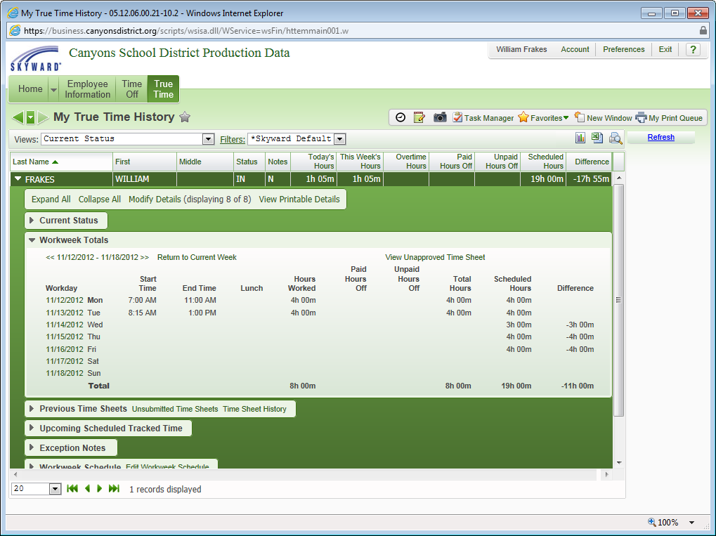
Click the arrows in either direction to move within the Time Sheets.
Or, click Return to Current Week to return to the Current Week.
From within Workweek Totals, you can View Unapproved Time Sheet if the Time Sheet had been submitted, but yet approved. Or, you can View/Submit Timesheet if you had not yet submitted the Time Sheet.
From the View/Submit Timesheet option, you can submit your Time Sheet for approval as previously described.

Previous Time Sheets
Previous Time Sheets allows you to view Unsubmitted Time Sheets and your Time Sheet History.
Click the Unsubmitted Time Sheets link as highlighted.

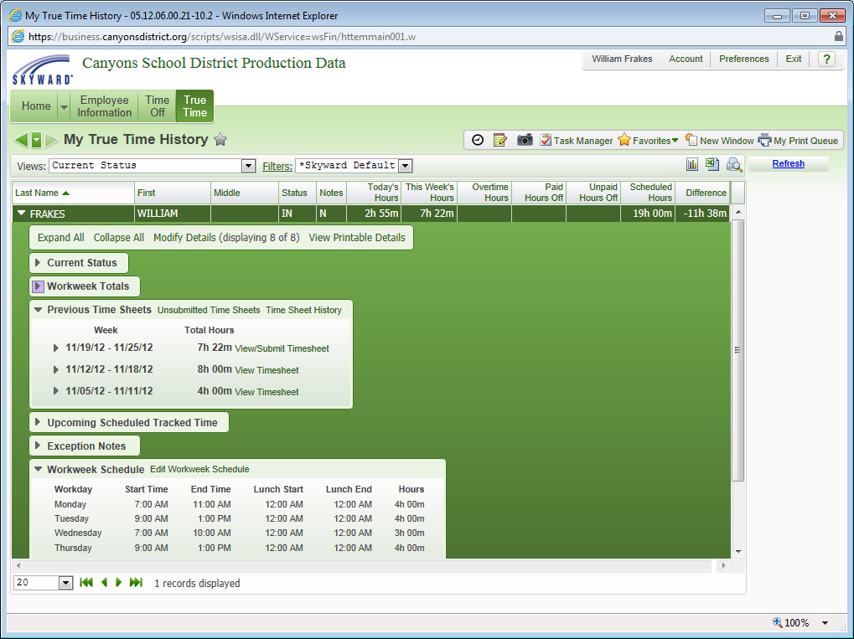
The following screen will be displayed.
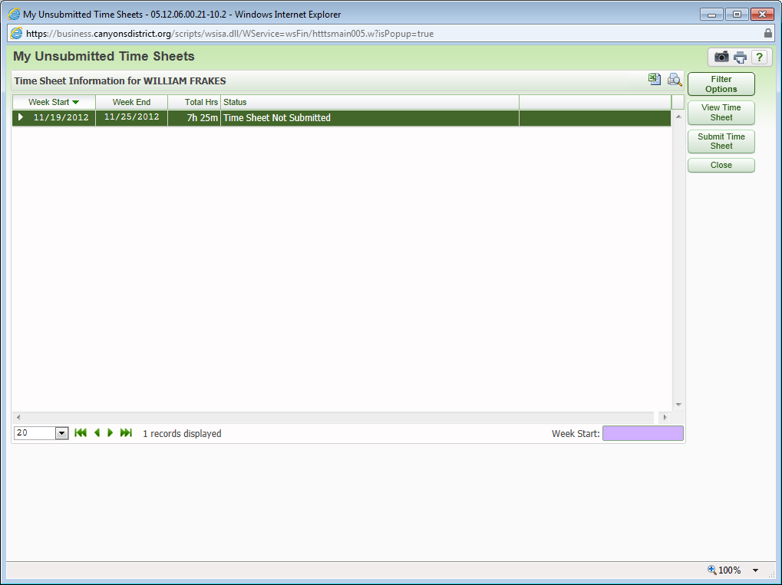
From this screen, you can view or submit your time sheet by clicking on either the View Time Sheet or Submit Time Sheet button as highlighted.
Click Close to return to the previous screen.

Click the Time Sheet History link and the following screen is displayed.
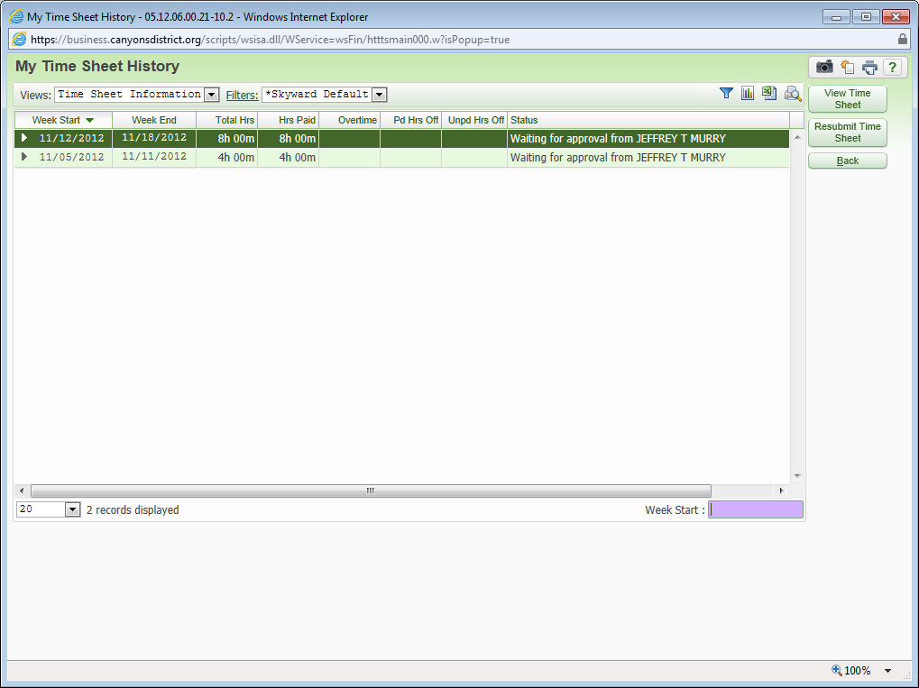
From this screen, you have the options to view or resubmit your time sheet.
Click the View Time Sheet button to view or the Resubmit Time Sheet button to resubmit your Time Sheet as highlighted.
Click the Back button to return to the previous screen.

Upcoming Scheduled Tracked Time
Click the arrow to expand and see Upcoming Scheduled Tracked Time.
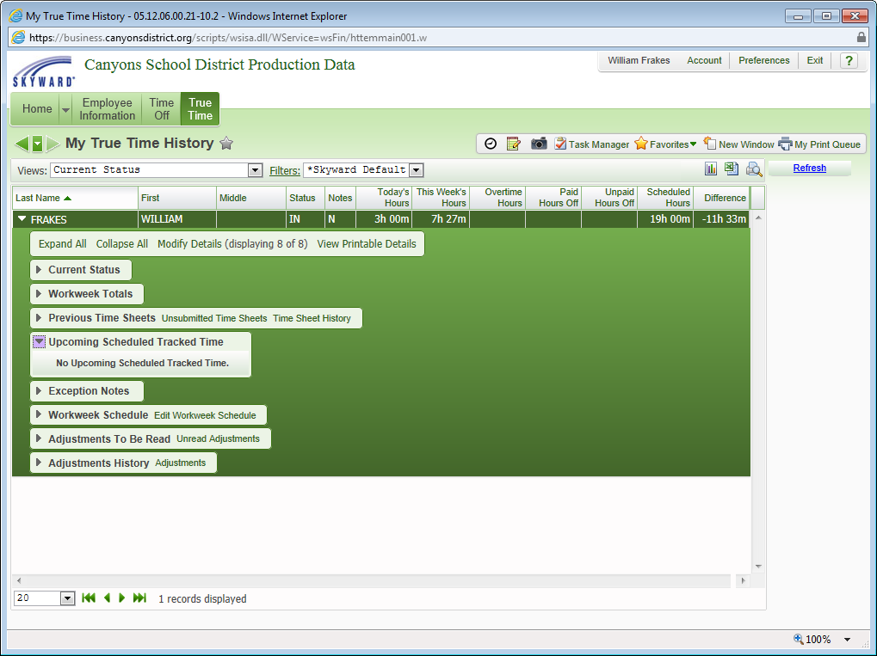
Exception Notes
Click the arrow to display Exception Notes to My Supervisor as displayed.
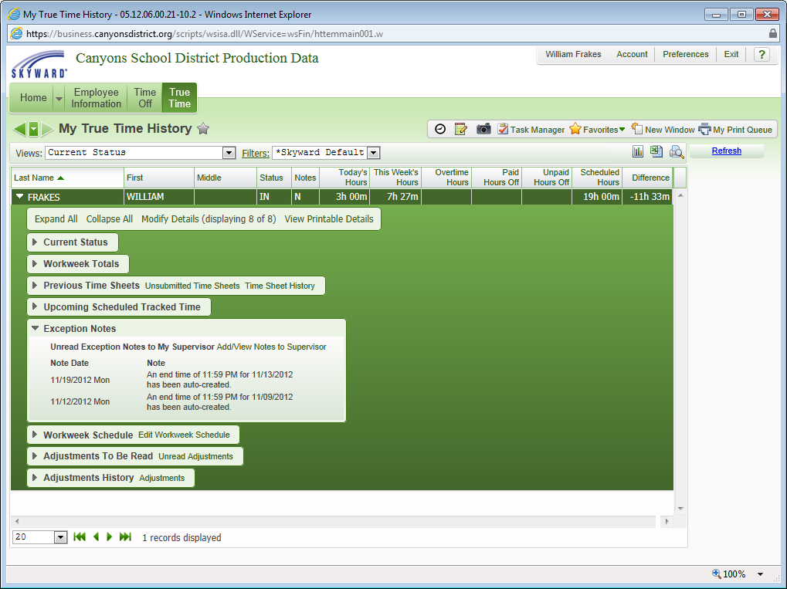
Click the Add/View Notes to Supervisor link to add or view notes for your Supervisor as shown.
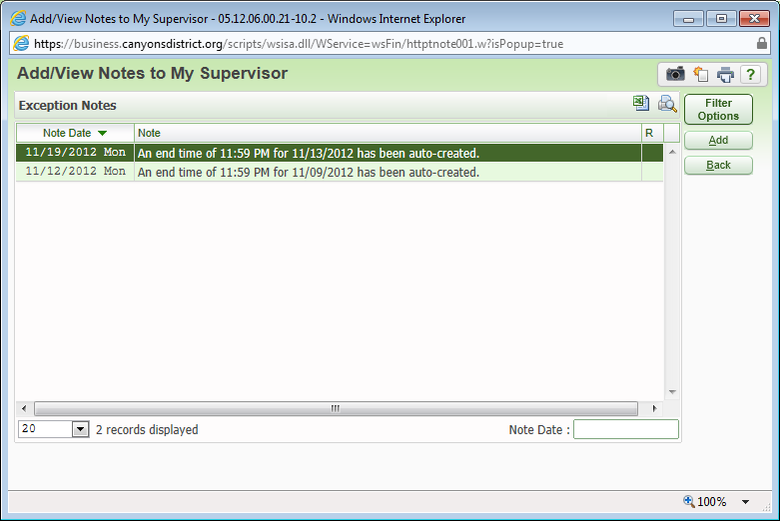
Click the Add button to Add Exception Notes as highlighted.
The screen will be displayed as follows.
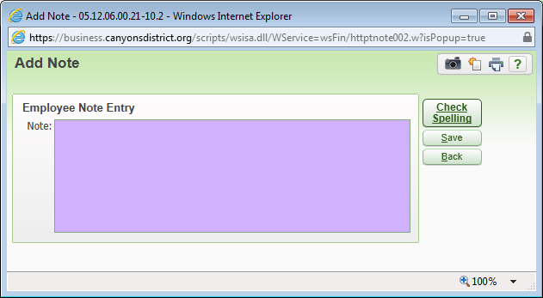
Enter you notes in the Note box.
Click the Save button.
The Check Spelling button is available to check spelling before submitting.
Click the Back button to return to the previous screen.

Workweek Schedule
Workweek Schedule displays the days and hours you are scheduled to work.
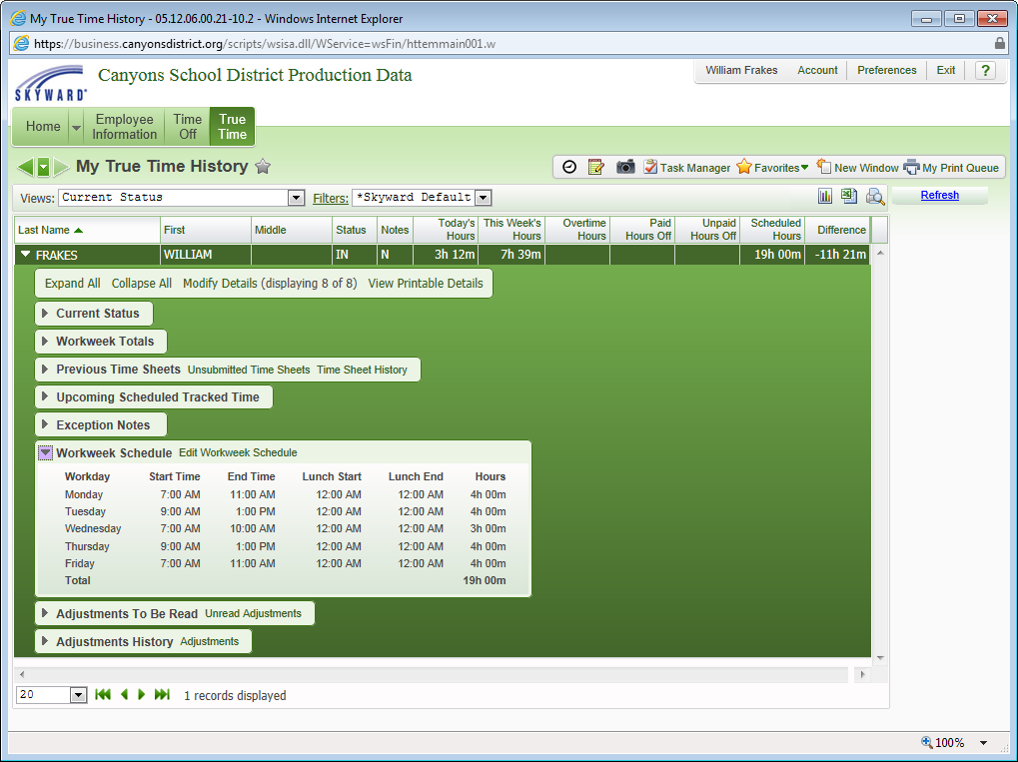
Click the Edit Workweek Schedule to make adjustments to your schedule as highlighted.
The screen is displayed as shown.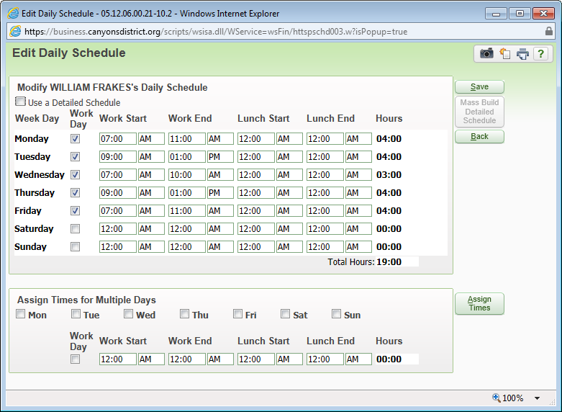
Make the necessary changes.
Click the Save button.
Click Back to return to the previous screen.

You can also modify your Daily Schedule from the My Setup link under True Time.
Click the link as highlighted.
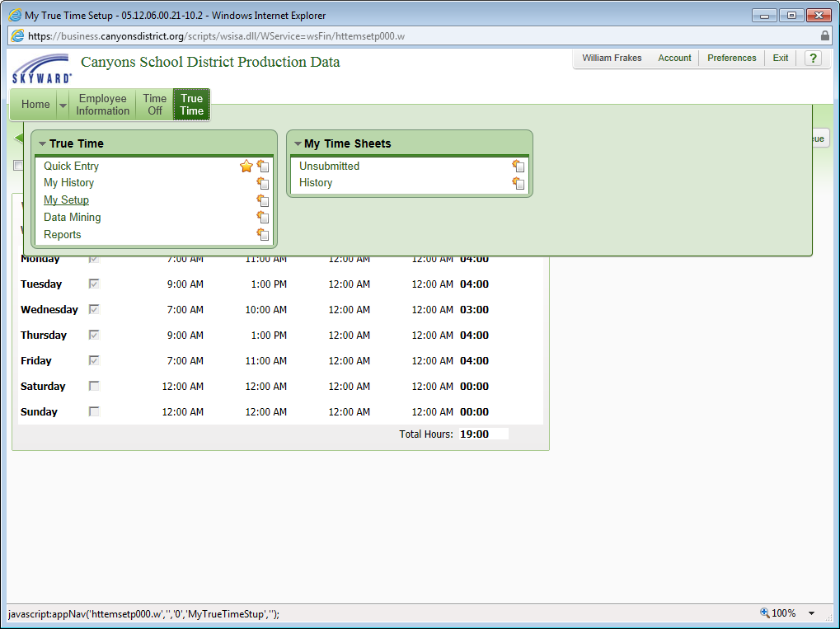
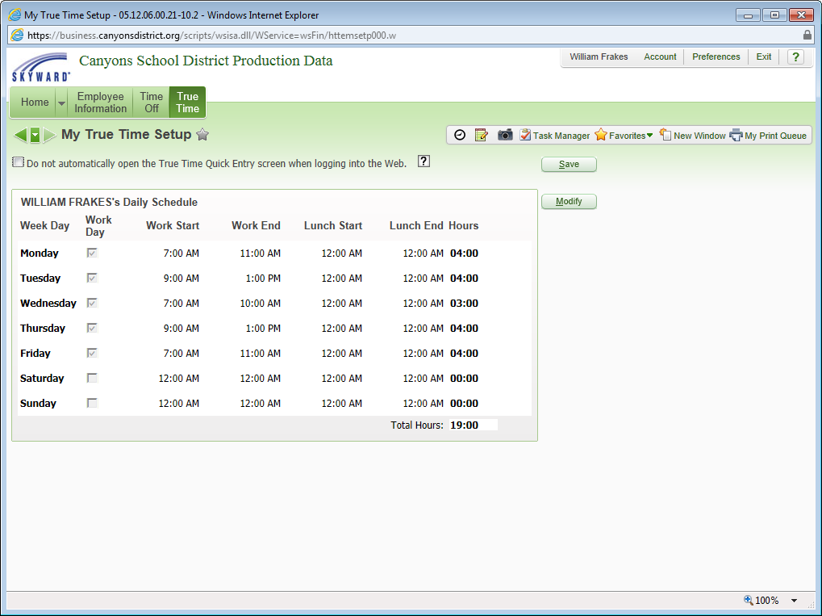
The following screen will be displayed.

Click the Modify button to modify your Daily Schedule.
Click the Save button to save your changes.

Adjustments to be Read
Click the arrow to view the adjustments.
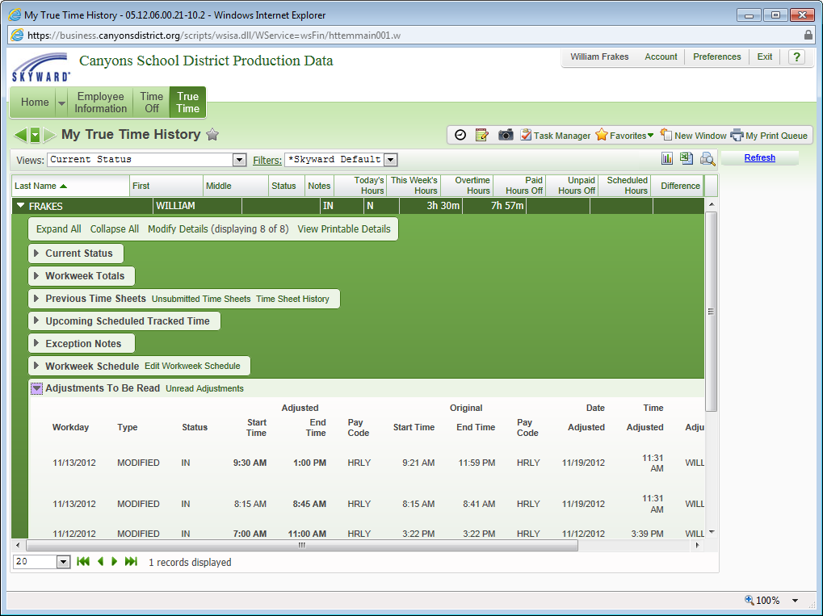
Click the Unread Adjustments link as highlighted.
The following screen is displayed.
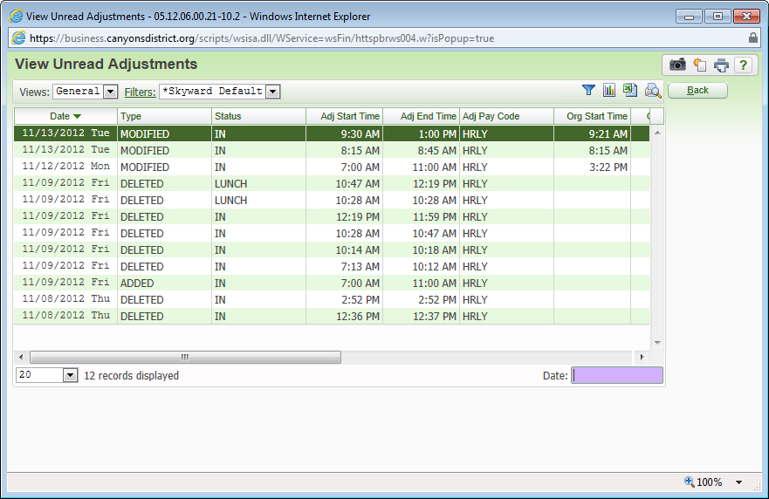

To view unread adjustments from a particular day, enter the date in the Date box as highlighted.
Click the Back button to return to the previous screen.
Adjustments History
Adjustments History displays Adjustment records that have been read by your Supervisor.
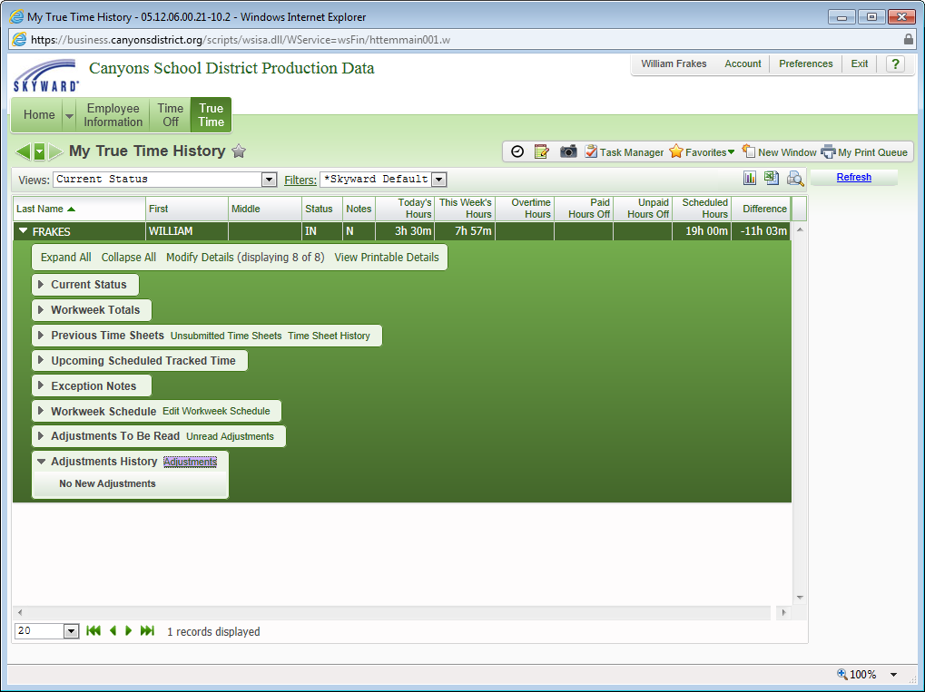
To view adjustments, click the Adjustments link as highlighted.

