THINGS TO REMEMBER: Approvers
- Approve every Monday morning.
- Check “Unsubmitted timesheets” when approving so you know who isn’t submitting weekly.
- Before approving timesheets, verify employees’ hours worked are correct. Payroll cannot verify this.
- If an employee needs to be paid from a different account, you must submit a change of account form to HR as soon as you are aware to ensure employee is paid out of the correct account.
- Any account corrections will have to be done via a journal entry through Accounts Payable.
Option A
- Log into Skyward Employee Access.
- Click on the button found on your toolbar on the right-hand side of the screen.
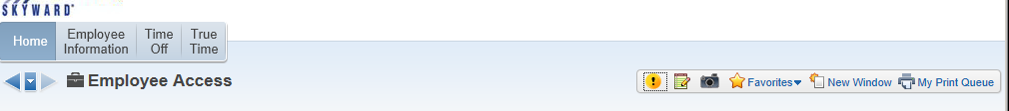
- Click on TRUE TIME TIME SHEETS. Go to Option B step 4
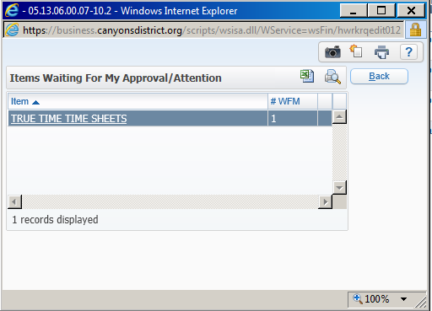
Option B
- Log into Skyward Employee Access.
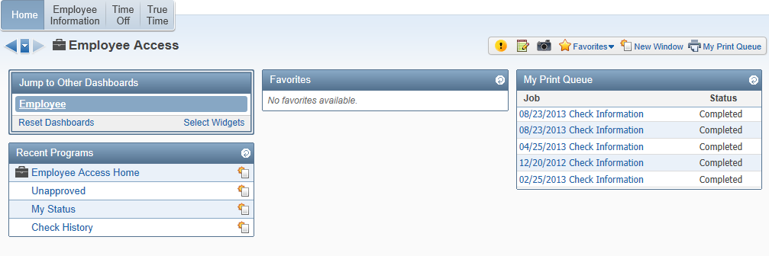
- Click on the 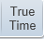 button.

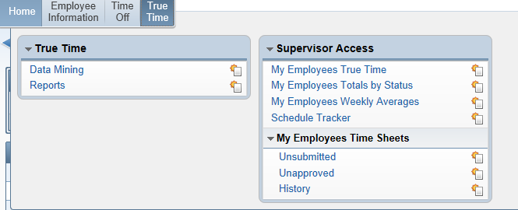
- Click on Unapproved.

- Click on  to approve one timesheet at a time or  to approve all timesheets at the same time.

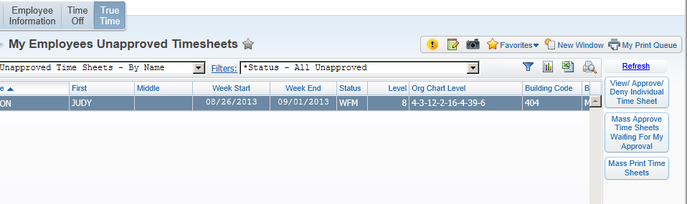

- Look over timesheet and click if everything looks correct. You may also print if you would like a hardcopy. Keep in mind, these timesheets are always available in History to view. You do not need a hardcopy for your files.
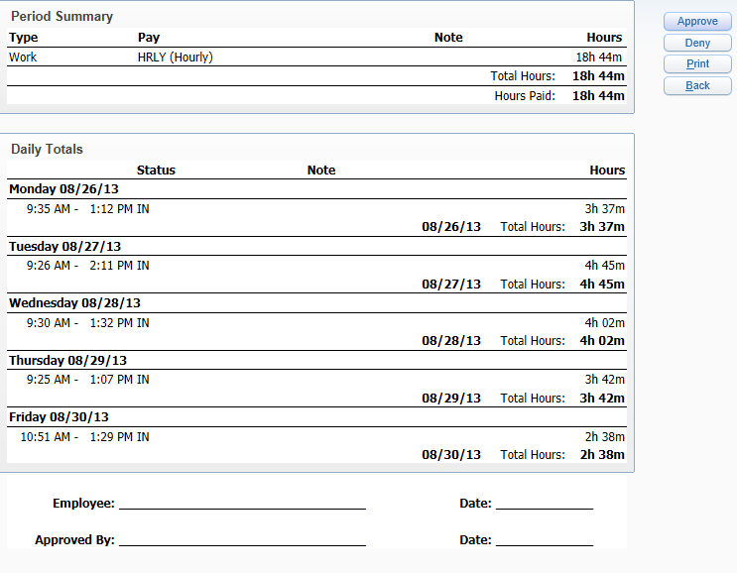
- If something needs to fixed on timesheet, click on and the timesheet will go back to employee so they can modify their time.
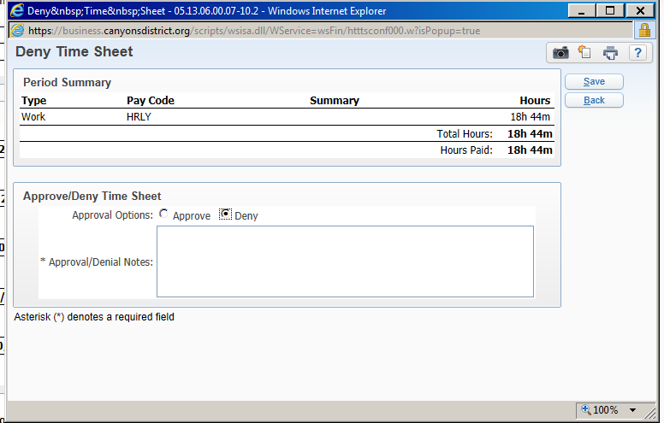

- If you denied the timesheet, in the notes field, type an explanation so the employee knows what needs to be corrected.
- Click on .
- The timesheet has been approved and sent to Payroll to be paid.

