What is my Employee ID and how do I find it?
Your Employee ID is a six -digit number assigned to each employee displayed in Employee Access.
- In your browser, go to skyward.canyonsdistrict.org
- Click on Employee Access
- Enter your Login ID and Password
- Click the Sign in button or press the Enter button
- Click on the Employee Information button
- Under Employee Information, click on Personal Information
- Your Employee ID is displayed under Custom Forms
- Click the link for Employee ID. Your name and Employee ID will be displayed.
In your browser, go to www.canyonsdistrict.org
Click on Resources

Click on Employee Access
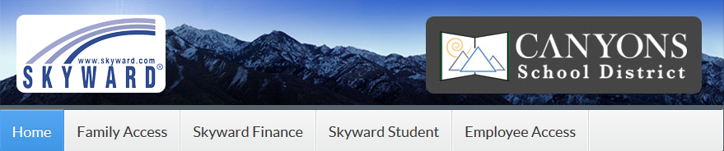
Enter your Login ID and Password
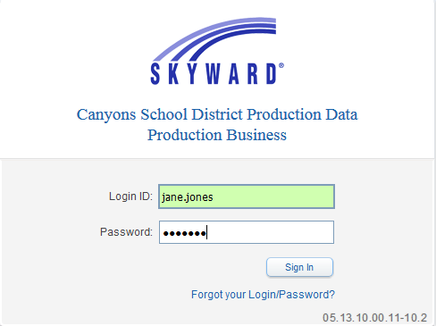
Click the Sign In button or press the Enter key
Click on the Employee Information button. Click on the Personal Information link.
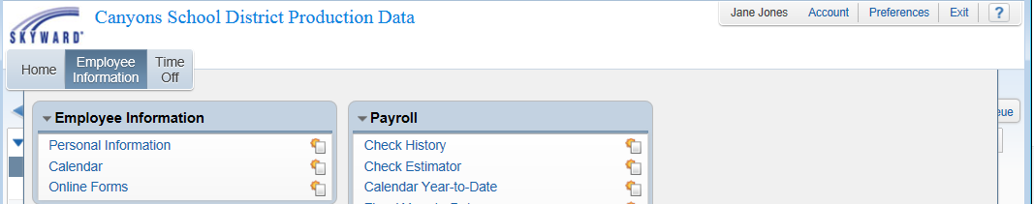
Click the next to Custom Forms to expand. Click the Employee ID link. Your Employee ID will be displayed.
