- Go to the www.canyonsdistrict.org (or go to skyward.canyonsdistrict.org and skip to step 4).
- Click on  in the top-center of the page.

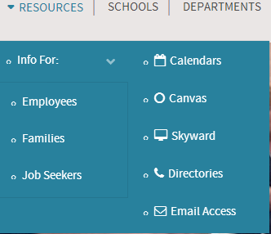
- Click on .
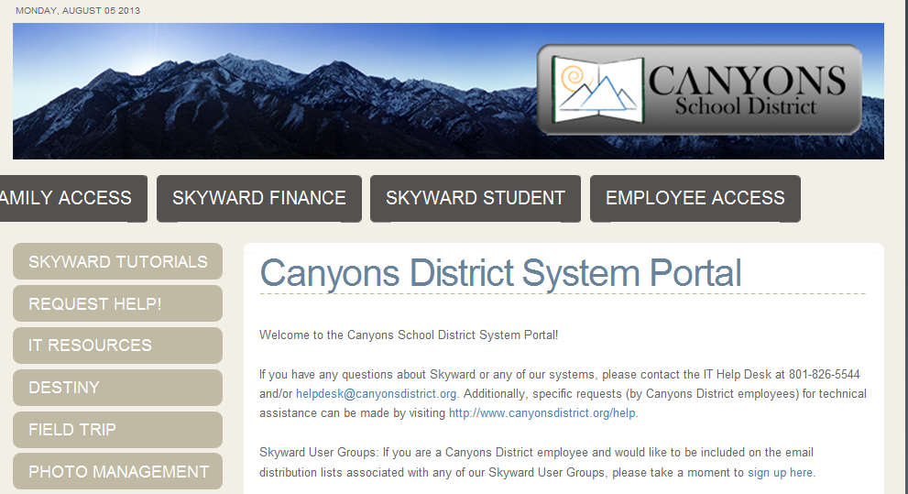

- Click on 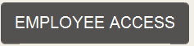 in the center of the page.
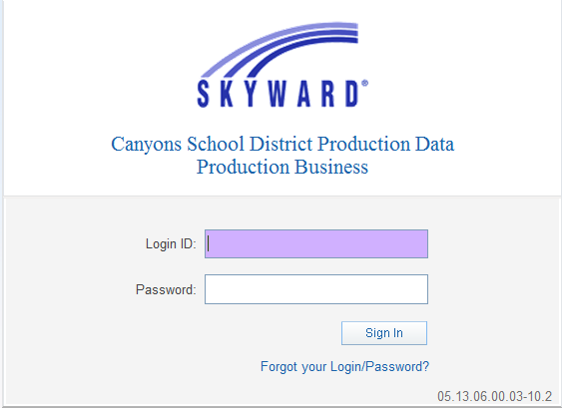
- Enter in your login and password. This should be provided to you by the IT department. If you do not have this or have forgotten your password, please call the IT Helpdesk at (801) 826-5544.

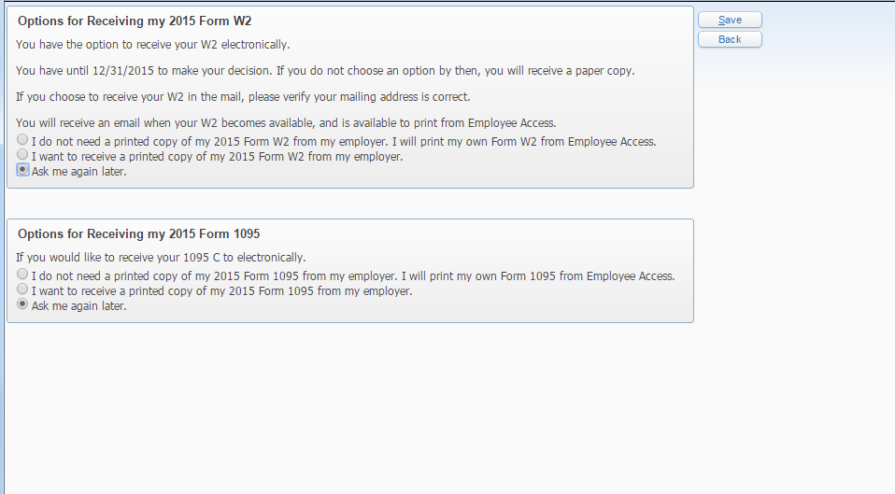
- Click on the radial button next to the message that says …

(At this time you can also choose to receive your 1095 insurance form electronically).
- Click .

