
Purchasing Card Reminders

- The Canyons School District implemented the U.S. Bank Visa Purchasing Card Program to facilitate the purchase and payment of small dollar purchases. The main purpose of this program is to establish a more efficient, cost-effective method of purchasing small dollar items.

- 3 Strike Rule - Improper card use will result in cancellation and disciplinary action, which could result in termination of employment (infractions are tracked and notices will be issued).

- Cardholder Monthly Spending Limit: This limit is the maximum dollar amount authorized for a cardholder with-in a 30-day period. Our billing cycle is from the 11th to the 10th. Unless the 10th is a Holiday or Weekend.

- Cardholder Single Purchase Limit: This limit restricts the amount of any single purchase. It is against policy to split transactions to stay under this single purchase threshold.

- The Purchasing Card is NOT intended to avoid or bypass appropriate purchasing or payment
procedures.

- You are responsible for the security of your card and the transactions made with it. The card is issued in your name. The card is not to be “loaned” out for others to use – this is a VISA, US Bank and a District policy.

- Immediately notify U.S. Bank Customer Service (1-800-344-5696) and the District Program Administrator (Darci Nash, 801-826-5391) if your card is lost, stolen or there is fraud on your card.

Complete monthly reconciliation by the 18th, US Bank locks your account on the 20th.
- Reconcile each transaction online. You must put a brief description of items purchased.
  - If you are trying to allocate to a particular account code that doesn't exist in US Bank, contact Daniel Davis in accounting (65359)
- Tax Exempt – Please remember to ask for tax to be removed
- Please place your receipts in order as they appear on your monthly statement!
- Itemized receipts required for ALL purchases
- Please tape small receipts to a blank sheet of paper.

The Purchasing Card is designed to be simple and easy to use, providing you with the materials needed to perform your job more quickly and efficiently. Please let us know how we can assist you.

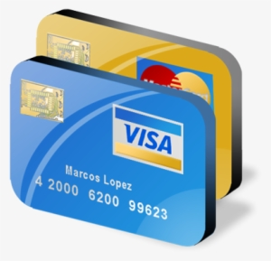
Darci Nash 801-826-5391 (Purchasing)
Ladenea Jenkins 801-826-5341 (Accounting)

